The Other Gunpowder Plot – in Bermuda
By David A. Welker, SMJC Historian
If you’ve been to the island of Bermuda you know about its pink beaches, its beautiful oceanfront scenery, and its impressive golf courses. But you probably have no idea of the important role it played in guiding our American Revolution through some of its darkest days.
Events begin in the wake of the June 17, 1775 Battle of Bunker Hill, when Patriot forces imposed a pyrrhic victory on British troops defending Boston. Virginia’s General George Washington, just appointed by Congress as the army’s commander, arrived in Cambridge, Massachusetts after that battle to discover his new command was a mess. Washington knew he could fix the manpower shortages he discovered, but he had no idea how to address his most vexing problem – a shortage of gunpowder. If Washington couldn’t acquire gunpower it would not matter how many men his army had to confront the British. He had been assured the army possessed 485 barrels of gunpowder, but upon arriving learned that in fact only 36 barrels existed. So stunned was Washington by this news that he famously retreated to his tent in silence for half an hour. Upon emerging, Washington set in motion his plan. The easy part was launching a deception campaign to convince his British enemies that the army actually had too much gunpowder, which worked, forestalling any British attack to exploit the truth. The hard part, however, was actually producing sufficient gunpowder and Washington lacked any idea for addressing that. Fortunately for him and the Continental Army, someone hundreds of miles across the sea had already set an answer in motion.
Bermuda has much to recommend it today as a vacation spot, but in the Eighteenth Century it was little more than a convenient, secure port for vulnerable sailing vessels. Most importantly, it was unable to produce sufficient food for its growing population and in 1773 had endured starvation conditions which local leaders were working desperately to avoid repeating. Complicating their efforts was that Virginia, the source of most of their food, was by 1775 in rebellion against Britian and had imposed an embargo barring any Virginia goods—including food—from reaching British colonies. With starvation once again threatening Bermuda, in March 1775 prominent local leader Colonel Henry Tucker conceived a plan that just might work to both Bermuda and America’s advantage - trading Bermuda’s gunpowder supply for Virginia foodstuffs.
Colonel Tucker was the descendent of one of the island’s original Virginia Company settlers and by 1775 was a former speaker of its House of Assembly (Bermuda’s version of Virginia’s House of Burgesses) and a wealthy local leader. Critically, two of his sons lived in the American colonies. Dr. Thomas Tucker was a South Carolina surgeon and St. George Tucker was a lawyer who had just graduated from Williamsburg, Virginia’s College of William and Mary, in the process building important ties with the Continental Congress’ President Peyton Randolph (today you can visit his home, the Tucker House, on Colonial Williamsburg’s Palace Green). Both were already ardent American patriots and the colonel at once turned to St. George’s contacts to reach Benjamin Franklin.
On June 30, 1775 Colonel Tucker sent his plan, the Bermuda Petition, to Franklin who on July 15th presented it to Congress. Two days later Congress declared it would lift the embargo for Bermuda if it could provide the gunpower. What Colonel Tucker had failed to mention in his Petition or related correspondence was that the gunpower was not his or Bermuda’s to give away; it belonged to the King and his local representative, Governor George Bruere, who had no intention of doing so. This left Colonel Tucker little choice but to steal the gunpowder.
One step ahead, to carry this out Colonel Tucker had in July created “The Committee,” which included among others his son St. George—visiting home after passing the bar—and cousins Henry and James Tucker. While it planned the theft, Colonel Tucker traveled to Philadelphia in July to make final arrangements with Franklin, including arranging two merchant ships—the Lady Catherine and the Charles Town and Savannah Pacquet—to “conveniently” be in Bermuda’s port and capital St Georges at the time of the planned action. On August 11th both ships left port to return to America, but seemed to struggle west under slight winds leaving both—again, conveniently—hovering off Bermuda’s coast through August 14th.
At dawn on August 15th someone discovered a damaged keg head and spilled gunpowder at the shore of Tobacco Bay. They next found the government’s thick stone powder magazine at Tobacco Bay had been broken into, a large hole now in its roof. Inside, was nothing. At the same time, the Lady Catherine and the Charles Town and Savannah Pacquet had both found the wind and were nowhere to be seen.
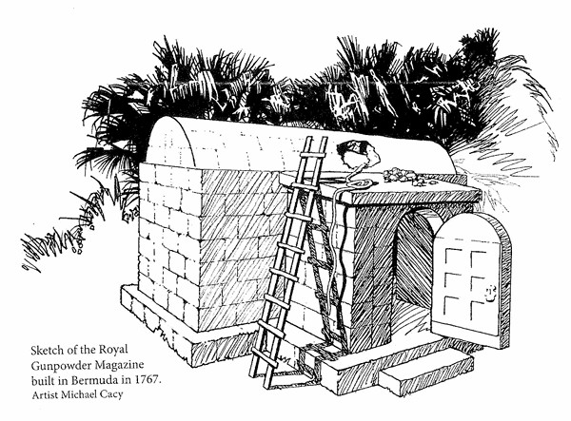
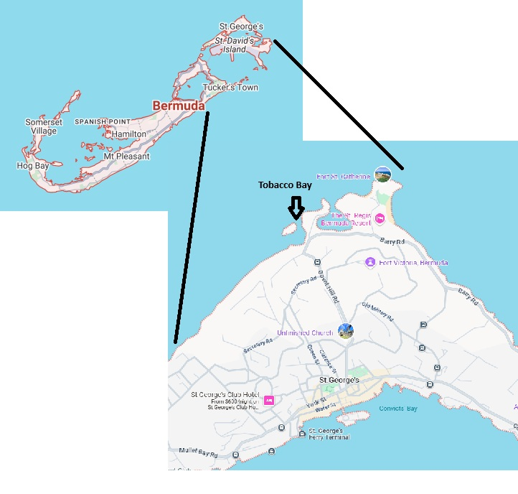
Governor Bruere was instantly notified ,and he was understandably furious. Ordering a boat at once to sea in search of the powder, it returned empty handed. To encourage others to join his hunt Bruere issued a Proclamation declaring “Save your country from ruin, which may hereafter happen. The Powder stole out of the magazine late last night cannot be carried far as the wind is light.” But it was too late.
During late August and September 1775, the two ships reached port in America, offloading 80 kegs, containing a total 1,182 pounds of gunpowder. Although the exact fate of Bermuda’s gunpowder remains a mystery, it certainly reached the front because although in June the Patriots had just 36 barrels, on September 20th the Pennsylvania Committee of Safety reported “sundry casks of powder sent to George Washington 2 Wagons, 4,012 lbs.” Looked at another way, Bermuda had provided enough gunpowder for 1,182 Patriot soldiers to have one pound of gunpowder each and was probably used during the Siege of Boston or the Quebec Campaign. Regardless where it was ultimately used, the tiny island of Bermuda indeed stepped forward to aid the Patriot cause at a critical moment.

