History of the Revolutionary War Hunting Shirt
By Chapter Historian David A. Welker
Today we in the SAR know the hunting shirt as perhaps the most visible sign of a militia impression at commemorative events, but this humble, uniquely American attire is far more than that – it is, in fact, nothing less than one of the premier symbols of American liberty and independence.
The shirt’s design dates to the 1730s, when hunters wandered the Blue Ridge Mountains’ backcountry seeking deer for hides to feed European demands for fashionable buckskin breeches, then the preferred pants for men ranging from the working classes to well-heeled dandies. These hunters later inspired James Fenimore Cooper to create the classic American marksman Natty Bumpo, the “Deerslayer,” while their lightweight, inexpensive, practical upper covering inspired uses long after fashion had moved on and demand for deer hunters diminished. By covering and protecting more costly, valuable clothing, the hunting shirt was quickly adopted by farmers, wagoners, and other laborers. Another attractive feature was that its loose weave enabled common men to indulge in a low-cost bit of fashion by creating fringe to their own tastes, inspired probably by interaction with Native American Indians.
Describing the hunting shirt, Massachusetts Revolutionary War veteran Simeon Alexander noted in his 1832 pension application that “the unform of Morgan’s regiment was a short frock made of pepper and salt colored cloth like a common working frock worn by our people, except that it was short and open before, to be tied with strings.” As Alexander noted, hunting shirts opened in the front and were held closed by strings and sometimes a belt, in contrast to the closed-front, pullover smock favored by farmers. Constructed from a variety of low-cost fabrics—chiefly linen, linsey-woolsey, tow fabric, and osnaburg—they typically were colored white, natural, or a half-bleach yellow, but other were died brown, black, pink, and purple. They usually featured short capes covering the shoulders, although this was probably more for design than to protect the wearer from the elements. Nearly all featured fringe along the hemmed edges—on the cape, collar, cuffs, and bottom hem—that was certainly ornamental, often created by the wearer to suit his fashion taste.
The hunting shirt’s first military use was by American militia in the French and Indian War. John Smith, who served as a ranger in Virginia’s Augusta County militia during that conflict, included a wartime hunting shirt in his will, marking it the first written record of this apparel. The first printed reference to a hunting shirt came on June 23, 1768 in a The Virginia Gazette ad alerting the public to runaway indentured servant George Wilkinson who “Had on when he went away a new felt hat, a hunting shirt, and calico waistcoat.”
Wat the American Revolution’s outbreak Patriot governments and communities searched for an affordable, available uniform for their new troops. Virginia became the first colony to adopt the hunting shirt as its uniform, declaring on March 29, 1775—two days after the Second Virginia Convention heeded Patrick Henry’s famous call and voted for independence—“that every man to be provided with a good rifle, or common firelock” and “to be clothed in a hunting shirt by way of Uniform.” Virginia’s militia companies widely adopted the hunting shirt, notably wearing them on General Daniel Morgan’s July-August 1775 “Beeline March” to Boston. Maryland’s Captain Michael Cresap described the Virginians as “armed with tomahawks and rifles, dressed in hunting shirts and moccasins…”
Upon arriving in New England, the Virginians’ novel hunting shirts gained attention throughout the Patriot camps. Connecticut Continental Congress delegate Silas Deane wrote his wife on July 1, 1775 that he wished “our (New England) troops would imitate their uniform, as it is cheap and light,” adding later that “I send on what is called the Shirt Uniform or rifle dress, as a sample or pattern, and wish that it may be adopted.”
When George Washington assumed command in July 1775, he quickly found his troops’ social and economic diversity—reflected by some wearing fine coats, others locally-provided short jackets, but most in common work clothes—undermined the new Continental Army’s unity. To address this problem Washington turned to the hunting shirt. Calling for “a number of hunting shirts, not less than 10,000” as new uniforms, which “would have a happier Tendency to unite the Men, & abolish those Provincial Distinctions which lead to Jealousy & Dissatisfaction.” Washington later sent a pattern to Rhode Island and Connecticut manufacturers, unfamiliar with the hunting shirt, to aid in filling the army’s order. When the Continental Army still lacked uniforms upon moving from Boston to New York, Washington on July 24, 1776, issued a General Order declaring the hunting shirt would be the army’s general uniform, noting “being sensible of the difficulty, and expence of providing Cloaths, of almost any kind, for the Troops…he (General Washington) earnestly encourages the use of Hunting Shirts… No dress can be had cheaper, nor more convenient, as the Wearer may be cool in warm weather, and warm in cool weather by putting on under-Cloaths which will not change the outward dress, Winter or Summer—Besides which it was a dress justly supposed to carry no small terror to the enemy, who think every such person a complete marksman.”
Washington knew this threatening image was real. When Virginia riflemen serving in Boston killed numerous British officers and men at long range, it cemented the hunting shirt’s fearful reputation for independence. So visible a sign of independence was the hunting shirt that in August 1775 Norfolk, Virginia British authorities had arrested Alexander Main, fifer in a local militia company, claiming that by publicly wearing a hunting shirt he was flaunting his devotion to independence.
Following the Revolution, the new American Army retained hunting shirts as its militia uniform and in 1808 used it for light rifle regiments’ wear as well. The hunting shirt’s last miliary use came during the War of 1812, but the army quickly discovered that now-affordable, plentiful woolen fabric was more durable for hard campaigning. By the war’s end in 1814, the venerable hunting shirt became a relic of a bygone era.
Today, only four confirmed examples of Revolutionary War-era hunting shirts remain:
- Captain Abraham Duryea Hunting Shirt, 1776: The only extent hunting shirt documented to have been used during the Revolution, Captain Duryea wore it during the 1776 Battle of Long Island in New York. Today it is displayed in the Washington’s Headquarters Museum in Newburgh, New York.
- The Linen Hunting Shirt of 1780: Reportedly worn at Valley Forge in winter 1776, it is very similar in appearance to one worn by the 2nd New Hampshire Regiment’s Captain Samuel Blodgett in John Trumbull’s 1786 portrait of him. It is owned today by the Museum of the American Revolution in Philadelphia, Pennsylvania.
- Linen Hunting Shirt, 1790: Reportedly owned by a New Hampshire soldier, it is held in a private collection.
- Michael Crow Hunting Shirt, 1799: Sown by Nancy Crow for her husband Michael to wear in their 1799 wedding, it is owned by Greene County, Pennsylvania’s historical society.
Although originating with Virginia, Pennsylvania, and North Carolina backcountry militiamen, the hunting shirt uniform was quickly adopted by troops in every colony and the Continental Army during the American Revolution. It remains one of the most distinctly American symbols of our patriot ancestors’ service and spirit.
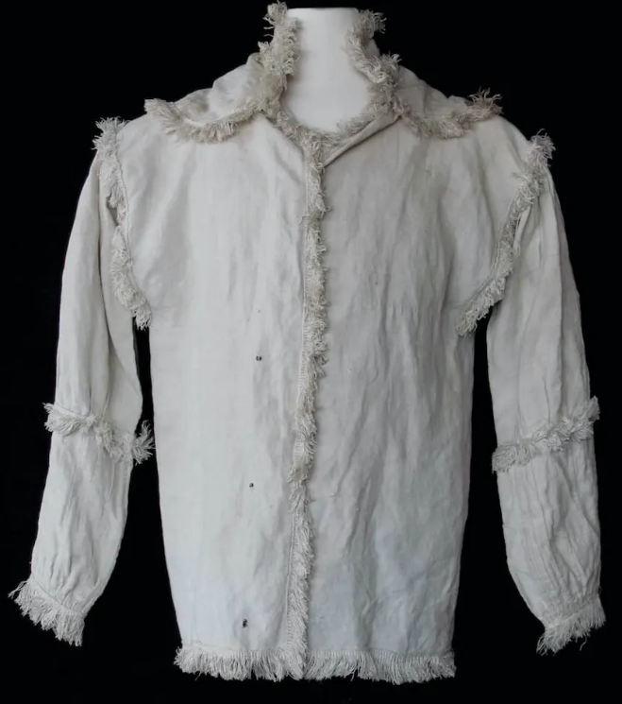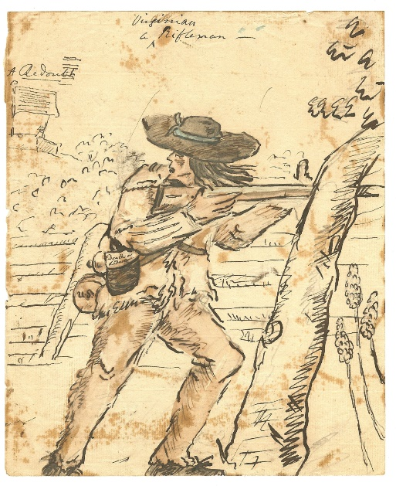
Hunting shirt in the Museum of the Wartime drawing of a Virginia rifleman
American Revolution’s collection

Neal Thomas Hurst, “The American Hunting Shirt,” Thesis, College of William and Mary, 2013, pp. 4-7.
Hurst, “The American Hunting Shirt,” pp. 47, 49, 51, 66.
Hurst, “The American Hunting Shirt,” pp. 10-14.
Hurst, “The American Hunting Shirt,” pp. 16-18, 23
Hurst, “The American Hunting Shirt,” p. 24.
Hurst, “The American Hunting Shirt,” pp. 24-25, 28-29.
Hurst, “The American Hunting Shirt,” pp. 1-3.
Hurst, “The American Hunting Shirt,” pp. 35-39.
Hurst, “The American Hunting Shirt,” pp.42-43, Appendix.

