Patriot Disaster at Kemp’s Landing
By SMJC Historian David A. Welker
From the moment in June 1775 that Virginia’s Royal Governor Lord Dunmore fled his palatial Williamsburg home for safety aboard British warships, he sought a way to return to land and reestablish his government and royal authority. Efforts to find a route back to Williamsburg had come up short, leading only to the October 26-27, 1775 Battle of Hampton, the first major fight in Virginia and a British defeat. Next, Lord Dunmore set his sights on nearby town of Norfolk. Not only would reestablishing royal control of Norfolk offer a secure port but the town was reputed—rightly, it turned out—to be chock full of Loyalists who might even swell his modest military force.
The first shot to take Norfolk came not from a firelock, but rather a printing press. On November 7, 1775 Lord Dunmore issued a Proclamation, which declared martial law throughout Virginia Colony and called call citizens to rally to the king’s cause. If appeals to loyalty wasn’t enough to end the rebellion, Dunmore added the threat that any slaves or indentured servants of Virginians rebelling against royal authority would be henceforth free and were encouraged to leave their masters and rally to the King’s colors. It was a bold strategic move that played both to Virginians’ fear of losing their costly human investment and of a potentially violent slave uprising.
Before announcing the Proclamation, Dunmore received intelligence that Williamsburg Patriot militia had arrived at Norfolk to forestall his landing. Worse was information that Rebel troops from North Carolina were heading there, too. Seizing the initiative, on November 14th Dunmore landed 130 British troops near Great Bridge to see if this was true and stop the Patriots.
Although supply shortages delayed the Williamsburg troops the North Carolina troops were a fiction, Patriots called out the Princess Anne County militia’s 170 men, commanded by Joseph Hutchings and Anthony Lawson. These troops mustered at Kemp's Landing, 10 miles from Dunmore’s target, and set up an ambush along the road to Great Bridge.
When Dunmore’s troops approached, the Patriot ambush collapsed instantly when the inexperienced militiamen exposed their position by firing prematurely. Dunmore's disciplined Regulars returned fire and moved through the woods to flank the Virginians. When the militia broke, Hutchings was captured by one of his former slaves and although Lawson escaped, he was captured a few days later. Worse, seven Patriots were killed and 18 captured. In contrast, just one British soldier suffered a minor wound. It was a Patriot defeat that seemed to undo the recent victory at Hampton.
Taking tiny Kemp’s Landing, Lord Dunmore raised the British flag and claimed the town. Compounding the Patriot disaster, 100 Patriot militia turned coat and swore allegiance to the Crown, claiming they had been duped into supporting the Rebel cause. On the back of his Kemp’s Landing accomplishments, Dunmore publicly announced his Proclamation. Marching on to take Norfolk unopposed, it seemed the tide had turned against the Patriot cause in Virginia.
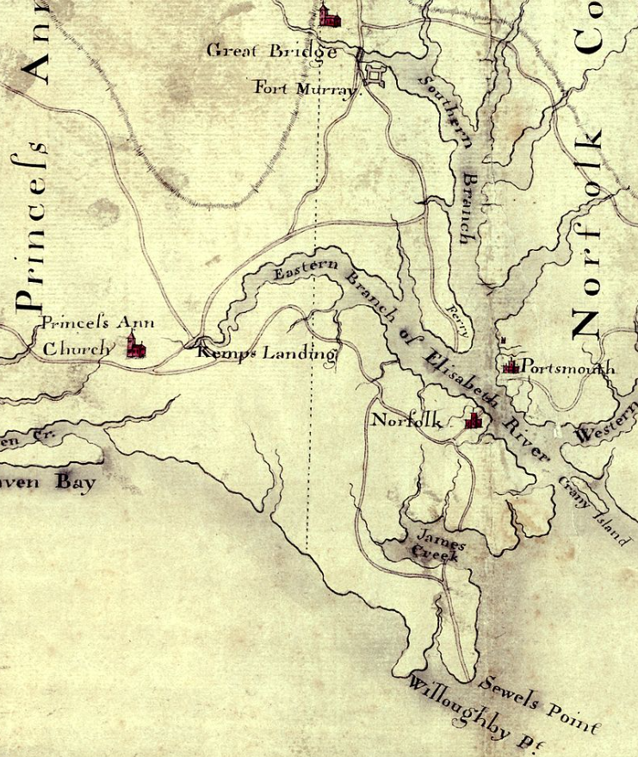
Note: This map is oriented with North at the bottom.

Yet Patriot militia that Dunmore had initially feared, Virginians heading south from Williamsburg and North Carolina militia heading north, were not imaginary as he had concluded. And at Great Bridge in a few weeks’ time, they would show just how real a threat they were.

