The Siege of Ft. Stanwix: The Rumor is Mightier Than the Sword
By David A. Welker, SMJC Historian
We all know that’s not the famous quote, but it might well have been if referring to the August 1777 Siege of New York’s Fort Stanwix.
Key to British General John Burgoyne’s August 1777 campaign to seize Albany New York—from which he could eventually control the Hudson River, splitting New England from the other rebellious colonies—was first securing the nearby Mohawk Valley. The key to taking the Mohawk Valley was controlling Fort Stanwix, near Rome, New York. To take this critical location, Burgoyne detached brevet Brigadier General Barry St. Leger and a 1,800-man force comprised of 800 British and Loyalist troops, along with 1,000 Mohawk Native American Indians under Mohawk Chief Joseph Brant. Defending Fort Stanwix was a force well under half that size, 750 Patriots of the 3rd New York Regiment, under Colonel Peter Gansevoort.
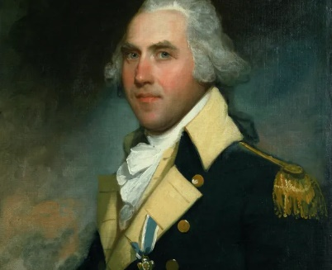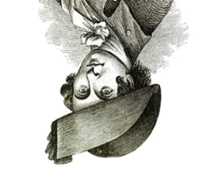

Colonel Peter Gansevoort Brevet General Barry St. Leger
Arriving outside Fort Stanwix on August 2nd, St. Leger demanded its surrender, which Colonel Gansevoort instantly refused. He did so knowing an American relief column was then enroute, led by Patriot General Nickolas Herkimer. When this column was stopped because St. Leger defeated it at the August 6th, Battle of Oriskany, Colonel Gansevoort turned a problem into an opportunity by sending 250 men from the fort to loot the vacant British and native camp. When St. Leger’s force returned, his Mohawk troops were unnerved by the loss of revered war trophies and other important personal items, which only widened already strained relations between the general and his Indian troops. Yet back in Ft. Stanwix, the Patriots’ situation was little brighter.
New help appeared on August 20th, when word arrived at the fort that American General Benedict Arnold appeared nearby. But Arnold possessed only 700 men, too few to defeat St. Leger’s force, and the Americans in any case would be divided. Yet the always clever Benedict Arnold had a plan.
First, he issued a broadside boldly declaring that anyone—Loyalists, Indians, Germans, or Britons—who within ten days fled the British lines and pledged loyalty to America would be spared the coming fight, while those two refused “must expect no mercy…”
Next, Arnold planted a rumor within the British camp that his attacking relief column consisted of 3,000 men and that they were coming fast. To carry this rumor Arnold recruited Dutchman Johannes Justus Schuyler (January 1, 1744 – 1810), known to all as Hon Yost. Although from a poor Mohawk Valley family, his mother was American General Herkimer’s sister, while his father was a cousin of American General Philip Schuyler. Hon Yost himself was described as “dim-witted, coarse and ignorant, a half idiot, a madman, and a lunatic,” but who also possessed "no small degree of shrewdness." Because of this, local Mohawks considered him special, perhaps as a prophet or someone who could interact with the supernatural. Hon Yost played this up, frequently socializing with the Mohawks, dressing as an Iroquois, and adopting their manners. Also like the Mohawks, he was a Tory and had helped the British gain local Indian support. But for whatever reason, Hon Yost was about to join the Patriot cause and the first act of this drama was hanging his coat in a tree to riddle it with bullets.
On August 22nd, 1777, Hon Yost raced into the Mohawk camp with an exciting story. Displaying his damaged coat to the Mohawks, he rambled on about a great American army that was coming at them fast. When asked how many men, Hon Yost reportedly simply pointed to a tree thick with leaves. When an Oneida man arrived next bearing a similar tale, the Mohawks had heard enough. Gathering their personal items—and looting others from some absent British and Loyalist soldiers—all 1,000 of them fled. The panic soon spread to the now-outnumbered British and Loyalists, who joined the Indians without even taking time to pack up their tents. General St. Leger’s army was gone in a matter of minutes.
At 3:00 several British deserters approached Ft. Stanwix reporting that “General St. Leger and his army was retreating with the upmost precipitation,” but Colonel Gansevoort smelled a trap. It wasn’t until 7:00 when Hon Yost arrived with news that Arnold was on his way with, that the mystery was resolved. When General Arnold and his 700 men finally arrived, they were welcomed into Ft. Stanwix with cheers. The Patriots had secured Ft. Stanwix without firing a shot.
It was a brilliant use of deception by Benedict Arnold that would pay even greater dividends when General Burgoyne arrived in late September, trying and failing to accomplish his goals in a campaign that would end in spectacular British defeat at the Battles of Saratoga. And it was all possible because Arnold proved that the rumor IS mightier than the sword.

