Virginia in November 1776’s Battle of Fort Washington
By SMJC Historian David A. Welker
Despite the mid-September American victory at Harlem Heights, seemingly-cautious British General William Howe and his force were on the march by early October, 1776, pressing American control of northern Manhattan Island. General Washington correctly judged that Howe would next want the nearby important road junction of White Plains, NY next and posted most of his forces there.
Contesting the enemy advance were the 1st and 3rd Virginia Regiments, now assigned as part of General Lord Stirling’s Brigade. By early November, however, these Virginians and Sterling’s Brigade crossed to the Hudson’s western bank at Haverstraw, to defend the approaches to the vital West Point position. Although some 1st and 3rd men may have hoped they would join their fellow Virginians in the other three just-arrived units, the 4th, 5th, and 6th Virginia Regiments had during that same time left the New York area to join General Hugh Mercer’s troops defending the Trenton, New Jersey area farther south.
These new postings meant no Virginia troops took part in the October 28 Battle of White Plains. Although Howe’s three columns turned the American right that day, Washington held firm and fell back to a new, stronger position. In response, Howe returned to his cautious state with withdrew his army to New York City to refit. Washington too pulled his army back, crossing the Hudson, leaving Fort Washington as the last American post on Manhattan Island.
Built on a 230-foot bluff overlooking the river, sited to threaten British ships, Fort Washington paired with Fort Lee in New Jersey, on the river’s opposite bank. Although Washington doubted his namesake fort’s value or defensiveness, he nonetheless yielded to General Nathaniel Greene’s insistence on holding the twin fortifications.
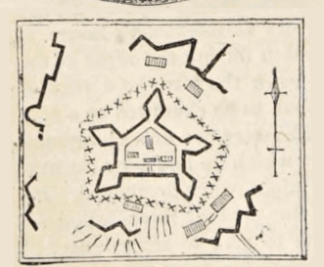
Among the Patriot forces holding Fort Washington was the Maryland-Virginia Rifle Regiment. Led initially by Colonel Hugh Stephenson—who headed one of the two first Virginia rifle companies in the Beeline March to join Washington’s army in 1775—after his 1776 death Maryland’s Lieutenant Colonel Moses Rawlins took command. Its four Virginia and four Maryland rifle companies, briefly divided between the two forts, in early November were joined together once again, in Fort Washington. There, the 250 Mid-Atlantic riflemen became part of Colonel Robert Magaw’s 2,800-man force and they arrived just in time. Rawlins’ Maryland-Virginia Rifle Regiment was at once posted on a hill just north of the fort to defend its approach from that direction.
British General Howe—just as Washington had feared and despite General Greene’s assurances—planned to secure Manhattan by first taking Fort Washington, before crossing the Hudson to strike Fort Lee. On November 16, Howe struck with his 8,000-man force, nearly four times larger than that of Fort Washington’s defenders.
First sweeping aside the few remaining Patriot defenders at Harlem Heights, General Charles Cornwallis’ second column routed American militia before turning to join Howe’s third attacking force at Fort Washington. This third column of 3,000 Hessians under Lieutenant General Wilhem von Knyphausen attacked the fort from the north about noon, running squarely into Rawlin’s riflemen.
The Maryland-Virginia Rifle Regiment poured a constant fire down into the attacking Hessians, making them pay for every upward step. As Patriot rifleman Henry Bedinger recorded: “Though at least five times our number, our rifles brought down so many of them that they gave way several times… This obstinacy continued for nearly an hour.”
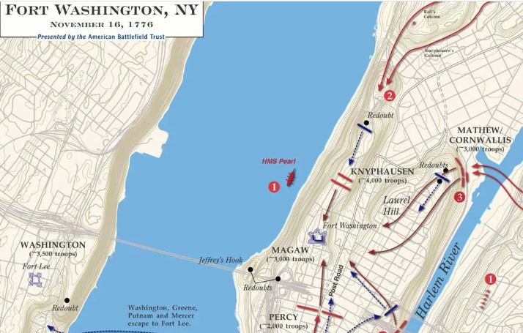
The Battle of Fort Washington
Supporting the Virginians on the hill was the two-gun battery from Captain John Martin Strobaugh’s Company of Pennsylvania Start Artillery. As notable as its fire that day was that when gun crew member John Corbin was killed, his wife Margaret Cochran Corbin, a camp follower, assumed his place on the gun crew, where she was severely wounded. In 1779, the Continental Congress recognized her service by awarding Margaret Corbin the first American military pension given to a woman.
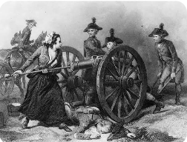
Despite this spirited defense, after an hour the Patriots’ rifles became increasingly fouled with unburned gunpowder, diminishing their fire. Sensing opportunity, General von Knyphausen ordered a bayonet charge that sent the American defenders racing for the fort. Once inside, the massed troops lacked positions from which to fire in defending the fort. By 3:00, after two hours of battle, Colonel Magaw was forced to surrender. The Battle of Fort Washington was not only a defeat, but nearly 3,000 Americans surrendered to a fate in the British prison hulks in New York harbor.
No longer cautious, Howe pushed Cornwallis’ column across the river on November 19th, immediately driving south for Fort Lee. Fearing a repeat of his army’s latest disaster, Washington ordered Fort Lee abandoned and his army to retreat southwest across New Jersey, heading for Trenton.
The New York Campaign of 1776 was over and it had been a disaster for Washington and his American army. However, Washington had learned valuable lessons that when the army reached Trenton he would apply in December and into the new year of 1777. The army’s officers and men too had learned much and were growing into battle-tested veterans. Throughout all the New York Campaign’s ups and downs, Virginians had been there, fighting for the cause of liberty. For better or worse, they and the Old Dominion were devoted to their revolution and the cause of American freedom. There was no turning back.

