Virginia Takes the Lead for Independence: June 1776
By SMJC Chapter Historian David A. Welker
In June 1776, Virginia placed itself at the forefront of independence, a position which until then had been held by Massachusetts and the New England colonies. Yet most Americans, even as we celebrate the 250th anniversary of these twin events, little know that these two momentous events occurred.
The first came on June 7, 1776, when Richard Henry Lee introduced his Lee Resolution to the Second Continental Congress in Philadelphia which declared that the thirteen United Colonies were "free and independent States" and separate from the British Empire.
Lee’s Resolution called for action on three issues, the most notable of which was its call for a vote on formal independence. Although this was delayed for three weeks—allowing delegations to receive guidance from home—on June 10, Congress decided to form a committee to draft a declaration of independence, in case the resolution should pass. The next day the Committee of Five (John Adams, Thomas Jefferson, Benjamin Franklin, Roger Sherman, and Robert R. Livingston) were appointed to draft what became the Declaration of Independence.
The Lee Resolution’s two other provisions built upon this declaration, demonstrating that the colonies were acting as an independent nation. These included negotiating treaties with foreign nations, and on July 24 Congress directed its commissioners to seek a treaty with France. Forming a new government for the United Colonies was the final component, setting in motion the process that eventually created the Articles of Confederation by mid-1777.
Lee’s Resolution was not Richard Henry’s alone, but rather he acted at the direction of the Fifth Virginia Convention and its president, Edmund Pendelton. From the start, this Patriot operated within a framework of law and established process.
The second event came on June 12, 1776, when the same Fifth Virginia Convention adopted George Mason’s Virginia Declaration of Rights, to establish '"the basis and foundation of government" under this new independence.
Containing ten articles, these established that Virginia’s new government would reflect:
- Inherent equality, that all individuals are "free and independent" and possess natural rights to life, liberty, and property.
- Popular sovereignty, that all power originates from the people and that governments exist for their common benefit. When government fails this, people have the right to reform or abolish it.
- Separation of powers, that legislative, executive, and judicial functions should be separate, yet equal.
- Civil liberties, that ensure freedom of the press, free exercise of religion, and the right to due process and a speedy trial by an impartial jury.
- Military subordination, that a well-regulated militia is vital to defending the state but it must remain subordinate to civil authorities.
If these ideas sound familiar, they should. Mason’s Virginia Declaration of Rights not only guided Virginia’s new government, but they became the philosophical foundation for the entire Revolution and greatly influenced drafters of the Declaration of Independence, our Constitution, and its Bill of Rights.
In June 1776, Virginia’s leadership in the “war of ideas” set the new nation on the path of liberty that it remains on today.

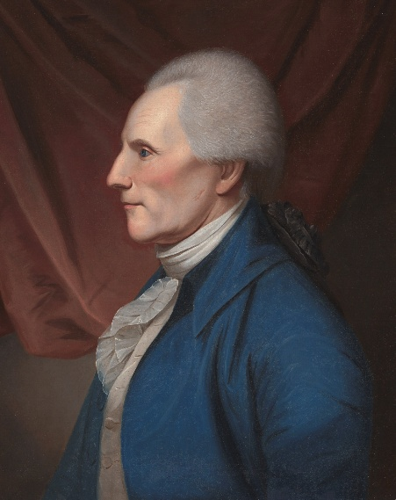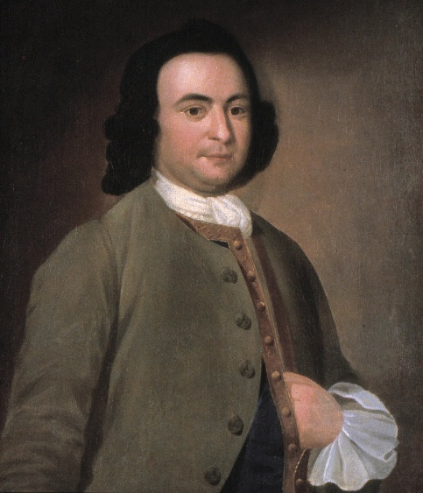
Richard Henry Lee George Mason

