The Spirit of Liberty Marches on, but Stumbles: Early Virginia Efforts to End Slavery
By David A. Welker, SMJC Historian
The same spirit of liberty that inspired Virginia throughout the American Revolution continued marching onward during the young republic’s early days. Having established American freedom, it inspired Commonwealth leaders even further, to begin abolishing slavery. Yet we all know that sadly, this flame died, requiring the costly devastation of the American Civil War to accomplish that goal. So, what happened?
Virginia, like all the 13 Colonies, had permitted African chattel slavery since its very founding. During the Revolution’s early days General Washington reversed his earlier opposition to placing Africans, free or enslaved, in the Continental Army’s ranks, driven by the need for military manpower and persuaded by the proven fighting skill and dedication of Rhode Island’s racially-integrated 1st Rhode Island Regiment. Many—perhaps most—Continental Army units eventually became integrated to some degree, enhancing the drive to freedom from Britain. This contribution convinced the very first session of Virginia’s legislature to ban the slave trade in 1778 – the first government in the Western hemisphere to do so.
When the war ended, this spirit joined with Quaker, Methodist, and Baptist Church efforts and persuaded the Virginia House of Delegates in May 1782 to pass “An Act to Authorize Manumission of Slaves.” For the first time in Virginia’s history, slaveholders could legally free their slaves, giving them wide personal discretion to do so without government approval. In response, many were granted their freedom, and in 1785 the three Christian denominations joined in petitioning the Virginia House to introduce bills for general emancipation.
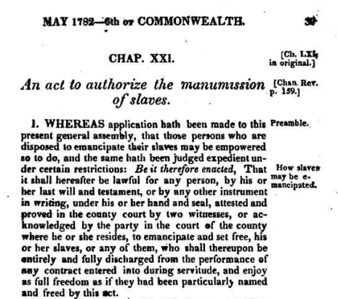
In 1783, Thomas Jefferson drafted an emancipation plan for the Virginia Constitution and in 1784 presented the US Congress a “Plan of Government for the Western Territory,” which prevented expanding slavery into the western territories after 1800. In 1785 the Virginia House voted that all slaves brought into the state would, after one year residing in Virginia, be declared free. Building on this, Virginia’s legislature produced throughout the 1780s a variety of laws that encouraged slaveowners to free those held in bondage. For example, one bill simplified the process by which slaves could petition the government for their freedom, granting also that the state would pay the petitioner’s court costs and offering other advantages. In 1785, Methodists persuaded delegates from Halifax, Amelia, Mecklenburg, and Pittsylvania Counties to submit nine emancipation petitions to the Virginia General Assembly. Both George Washington and Patrick Henry privately supported this movement toward general emancipation.
These actions in 1798 persuaded Virginia’s Robert Carter III, possessing the vast landholdings of his grandfather Robert “King” Carter, to issue his Deed of Gift that eventually freed all of his legion of slaves. Here in Northern Virginia, freeing slaves of his Leo Planation—so numerous were his farms that he named them after signs of the zodiac—created free Black families that still today have local roots.
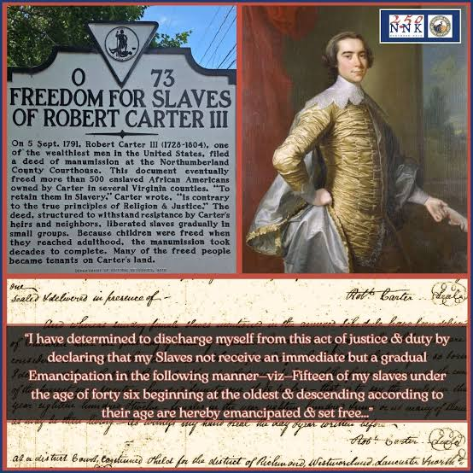
By 1791, these efforts had freed some 10,000 Virginia slaves, with no visible social or economic disruptions. The price of slaves had dropped to a 20-year low and the 1790 census showed that slaves now comprised just 40 percent of the state’s population, a new low rate. Such results sparked plans in the Virginia House for general emancipation, in which slave owners would be compensated by the state for their financial loss, as was being done in growing numbers of northern states. It seemed that liberty was again on the march…until it wasn’t.
A similar debate in the First US Congress in February 1790 about the future of slavery soon affected deliberations in Virginia. Nationally, powerful slaveholding interests went on the attack to quash general emancipation, similarly emboldening pro-slavery interests in Richmond. Although Virginians played a leading role in both factions in Congress, James Madison sadly became a leader in the pro-slavery faction, arguing that this was a step too far, too early for the young nation facing so many challenges. Congress narrowly voted 29-25 to bury abolition proposals.
On the heels of this missed opportunity came the 1791 slave uprising in France’s Saint-Domingue Colony, which in that year alone cause thousands of deaths on both sides. Ongoing violence spread, sparking the 1791-1804 Haitian War of Independence that ignited fear in Southern colonies that this could be repeated in America. In response, it seemed safer to emphasize the status quo, including securing the institution and legal protection of slavery.
Liberty’s march had taken a diversion, but could not be stopped. Although it would take another great war to set the issue aright nationally, we should remember Virginia’s early, bold moves to make the Declaration’s promise ring true for all.

Andrew Levy, The First Emancipator: Slavery, Religion, and the Quiet Revolution of Robert Carter (Random House: New York, 2005), 101.
Levy, The First Emancipator, 117-118.
Levy, The First Emancipator, 136-173.
Levy, The First Emancipator, 138-139.
Levy, The First Emancipator, 118-119.
Levy, The First Emancipator, 140.

