The Battle of Hampton: Virginia Fires Her First Shots of the Revolution
By David A. Welker, SMJC Historian
On October 26, 2025 the nation and SAR will celebrate the October 26-27, 1775 Battle of Hampton. Yet few know much about this important moment in Virginia’s Revolutionary War history.
Events began in September, 1775, building on simmering tensions between Virginia Patriots and Royal Governor Lord Dunmore which had forced him to flee for safety aboard nearby British warships. Yet the governor hadn’t given up. With the 20-gun HMS Mercury and 16-gun HMS Otter, he first sailed to Norfolk to gather British Regulars to support his plan for retaking a portion of Virginia and restoring Royal authority ashore. First, however, he needed supplies.
These were seized by sailors from HMS Otter, commanded by Captain Matthew Squire, in a series of lightning raids of towns and homes around Hampton Roads. Squire had already made himself an enemy of locals by granting freedom to any slaves who could reach the coast. To advance the governor’s plans, Captain Squire and a sailor—an escaped local slave who knew the area well—had taken the small British tender Liberty to scout possible water approaches to attack and retake Williamsburg. But before they could return to the Otter, a September 2 hurricane beached their small ship, among other damage it caused, forcing the two to flee overland to the coast. Although they reached the Otter and safety, local militia found and burned the Liberty in retaliation for Squire’s earlier raids. The captain had embarrassingly lost a ship to the rebels and he wanted revenge.
Expecting British retaliation, Hampton locals asked the Williamsburg Committee of Safety to send troops. Soon 200 volunteer militia had arrived, reinforced by early October when a company of minutemen and the 660 men of the 2nd Virginia Regiment, commanded by Colonel William Woodford, arrived. Attached to the 2nd Virginia was Captain John Green’s company of riflemen from Culpepper, who would very soon make a name for themselves.
The British struck late on October 26th, when Captain Squire led a five-ship flotilla of two armed sloops and other small vessels from Dunmore’s fleet to bombard Hampton town. First stopping briefly for Royal Marines to raid a local home, by dawn they were anchored some 300 yards offshore, blocked only by sunken obstacles local Patriots had placed to protect the town. Soon, Patriot troops began appearing and tensions flared.
Both sides reported their opponent fired first, but one thing they agreed on was the intensity of the fire. The 2nd Virginia and Patriot troops fought from a breastwork the militia had thrown up at the town’s wharf, while the British ships used the range offered by the 10

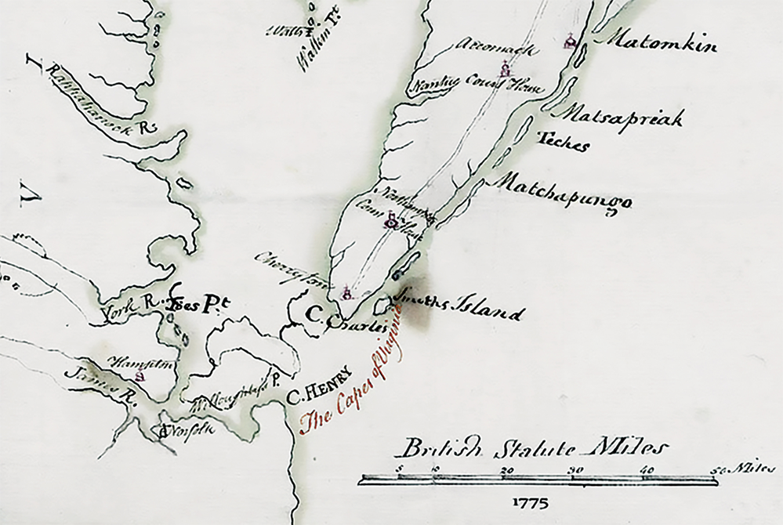
six-pounder guns stationed fore and aft in each of the sloops to strike the town and its Patriot defenders. For the next hour the two sides engaged in an intense ship-to-shore battle.
As later reported to Thomas Jefferson, likely from a participant, “Cannon Balls, Grape Shot and Musket Balls whistled over the Heads of our Men, Whilst our Muskets and Rifles poured Showers of Balls into their Vessels and they were so well directed that the Men on Board the Schooner in which Captain Squires himself commanded were unable to stand to their 4 Pounders…but kept up an incessant firing of smaller Guns and swivels…for more than an hour.”
It was the well-aimed rifles of Captain Green’s Culpepper men that had made it impossible for the British sailors to operate their large guns. The letter to Jefferson added “I can assure you that about 20 Rifle Men had disputed the Man of War and her Tenders… It is incredible how much they dread a rifle.” A legend was born.
Captain Squire had never encountered these Patriot riflemen and, probably in response to rising casualties, sliced his ships’ cables—abandoning their anchors—to sail away in retreat. In the chaos, one of Squire’s tenders became stuck on a bar, forcing the crew to flee in panic. In the process, a Patriot rifleman shot and killed the boat’s commander British Lieutenant Wright and captured five other sailors.
Beyond this loss the number of casualties remains uncertain, but it was clear that the Patriots had won the Battle of Hampton. Not only had the British ships fled and the city of Hampton been protected, but Lord Dunmore was sent a clear message. As one local newspaper reported “Lord Dunmore may now see he has not cowards to deal with.” Even so, Dunmore was hardly ready to give up, as the coming months of 1775 soon showed.
The Battle of Hampton was in the end a significant Patriot victory, despite its modest tactical gains. It was the first battle in Virginia—in any Southern colony—and this American victory was a much-needed morale boost, the first battlefield victory since the June Battle of Bunker Hill. The war in Virginia, however, was just beginning…

