Fry’s Travelling Companion Flask Set
Featured here is a “Fry’s Travelling Companion” flask set, stamped “1863.” A similar set was carried by an unnamed captain in probably the 15th Massachusetts Volunteer Militia’s Company B (see photo of the scratch-inscribed cup, below). W. T. Fry and Company—located at 134-136 William St in New York City—was selling glassware, leatherwork, and engraved metal items during the war, although the company may have begun life as a bookbinder, working as early as 1859. By 1867, however, the company had closed, offering all its inventory for sale after Christmas 1866 (see add, below). Fry and Company also sold less costly and elaborate flask and cup sets during the war, replacing the leather case with a leather, formfitting sleeve covering the glass above a cup, which was made of low-cost pewter or tin.
The featured set was probably expensive for the era, given its worked leather case and silver cup. Also unique about this set is that it bears a separate stamp of the local company that first sold it, “Geo. P. Rose, Elmira, N.Y.” George P. Rose (1822-1907) operated a jewelry shop in Dundee, NY—a village north of Elmira—as early as 1842. His son George P. Rose, Jr. took over the business in 1852 and may have moved the business to Elmira or opened a branch there.

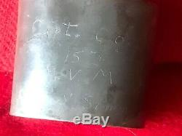

Scratch-inscribed “Capt. Co. B 15 MVM”

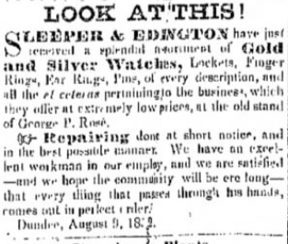

Add for George P. Rose Co.

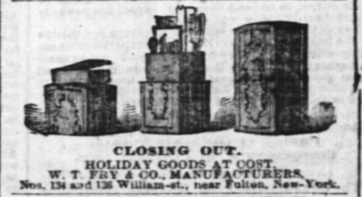
W. T. Fry Company’s Closing Sale Ad
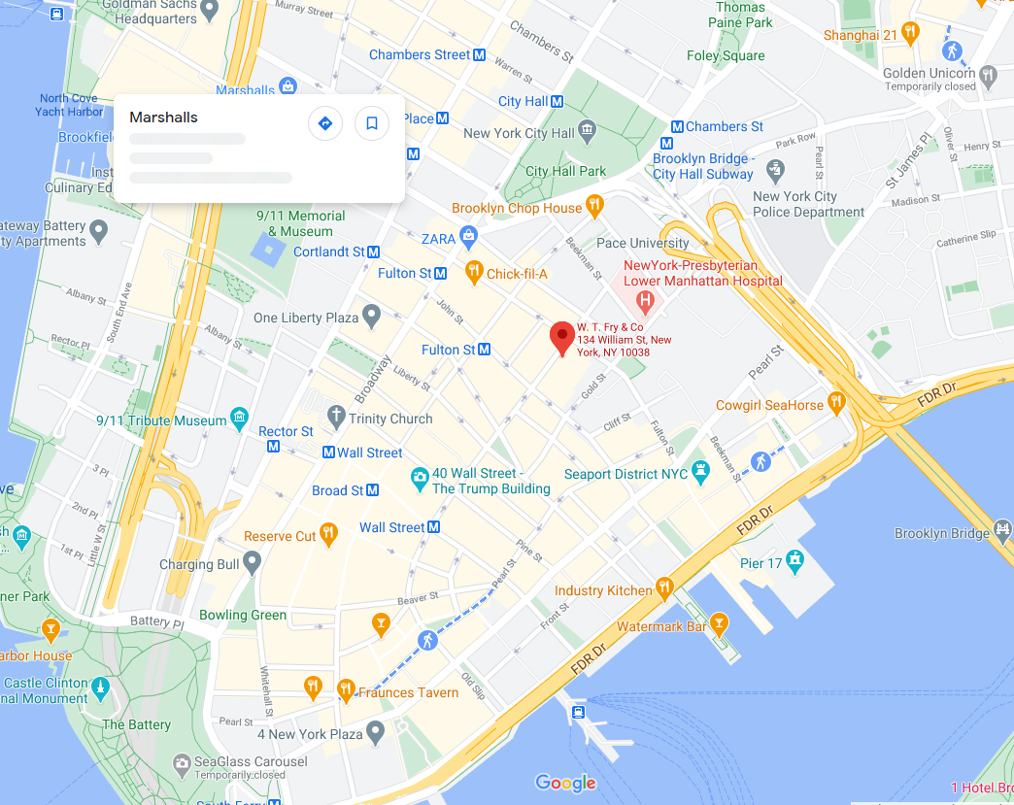
Location of W. T. Fry & Company during the Civil War

